Lesson on Using Gestures to Express Personality Traits

SHAPE America Grade-Level Outcome
S1.E11.5 Combines locomotor skills and movement concepts (levels, shapes, extensions, pathways, force, time, flow) to create and perform a dance with a group.

SEL Competencies:
Self-awareness: The ability to understand one thoughts, emotions and values.
Social awareness: Recognizing strength in others; Understanding and expressing gratitude
Relationship skills: Communicating effectively

Lesson Objectives:
- Students will perform physical gestures that describe something about their own personality.
- Students will teach their gestures with two others and discuss with them why they chose the specific gesture.
- Groups of three students will connect their three gestures into a movement sequence.

Equipment Needed: Bluetooth player, iPhone, Handouts for each student or a PowerPoint displayed

Managerial Task: Students are gathered in “calling all kids” area.

Lesson Introduction:
WHAT: Teacher explains that students will perform physical gestures that describes something about their own personality. The teacher will provide an example. Are you quick to anger? If so, you might perform a sharp, large assertive movement!
WHY: Is it important to think about our own personality traits and how they benefit ourselves and possibly affect others.
HOW: You will know you have achieved the lesson objective when you have been able to share and verbally describe your gesture/movement with two other students in class and cooperate with them to create a movement sequence.

Informing Task: The teacher will explain the “what” of the lesson and provide a gesture/movement example that expresses something about their own personality. They will physically perform and then verbally describe why they chose the specific personality trait and movement. The teacher can also demonstrate how to perform the movement at different levels, on different body parts, very large or very small.

The teacher will then provide a word bank (i.e., handout or PowerPoint Slide) of personality traits for students to use as a resource for creating their physical gesture. The movement framework will also be provided as a resource for creating their physical gesture. The teacher will point out the “space” and “effort” component.

Transition Task: Dismiss students to find a personal space by learning teams; play music while students are moving to their own space.

Introductory Task: Students create their gesture based on a personality trait they have selected.

Teacher’s Role: Circulate among students and using guided discovery help them with creating their gesture.

Extending Task: Have students make their gesture large, small or perform it at a different level.

Transition Task: Create several groups of 3 students using (teacher generated)

Extending Task: Students teach each other their gesture and explain why they created their gesture. Groups then put their gestures into a movement sequence.

Teacher’s Role: Circulate among students and using guided discovery help them to connect their gestures.

Optional Task: Students can verbalize, using one word, their personality trait while they perform their gesture.

Demonstrations: Ask for groups of three to share their movement sequence. Musical selection is played

Transition Task: Gather students in “calling all kids” listening area

Closure: Ask students to do a “think-pair-share” activity discussing what and why they created gestures for this and how their gestures described something about themselves. The teacher should also summarize how students achieved the lesson objective.

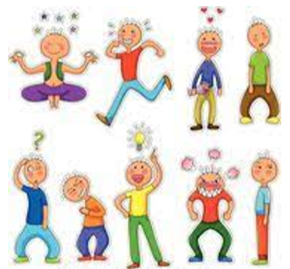

Agreeable
Optimistic
Shy

Conscientious

Anxious

Generous

Patient
Curious
Impulsive

Joyful
Energetic

Cautious

